Stage 1 Project Roadmap
Healthcare Integration & Clinical Terminology Test Harness — FAZ Australia (MedTalk Connect)
This roadmap covers Stage 1 only (Semester 1, Weeks 1–12), aligned to the ICT942 unit outline and its assessment checkpoints (Assessment 1 – Week 5, Assessment 2 – Weeks 8–9, Assessment 3 – Week 12). Stage 2 (build and test) begins next semester and is only planned, not implemented, in Week 10.
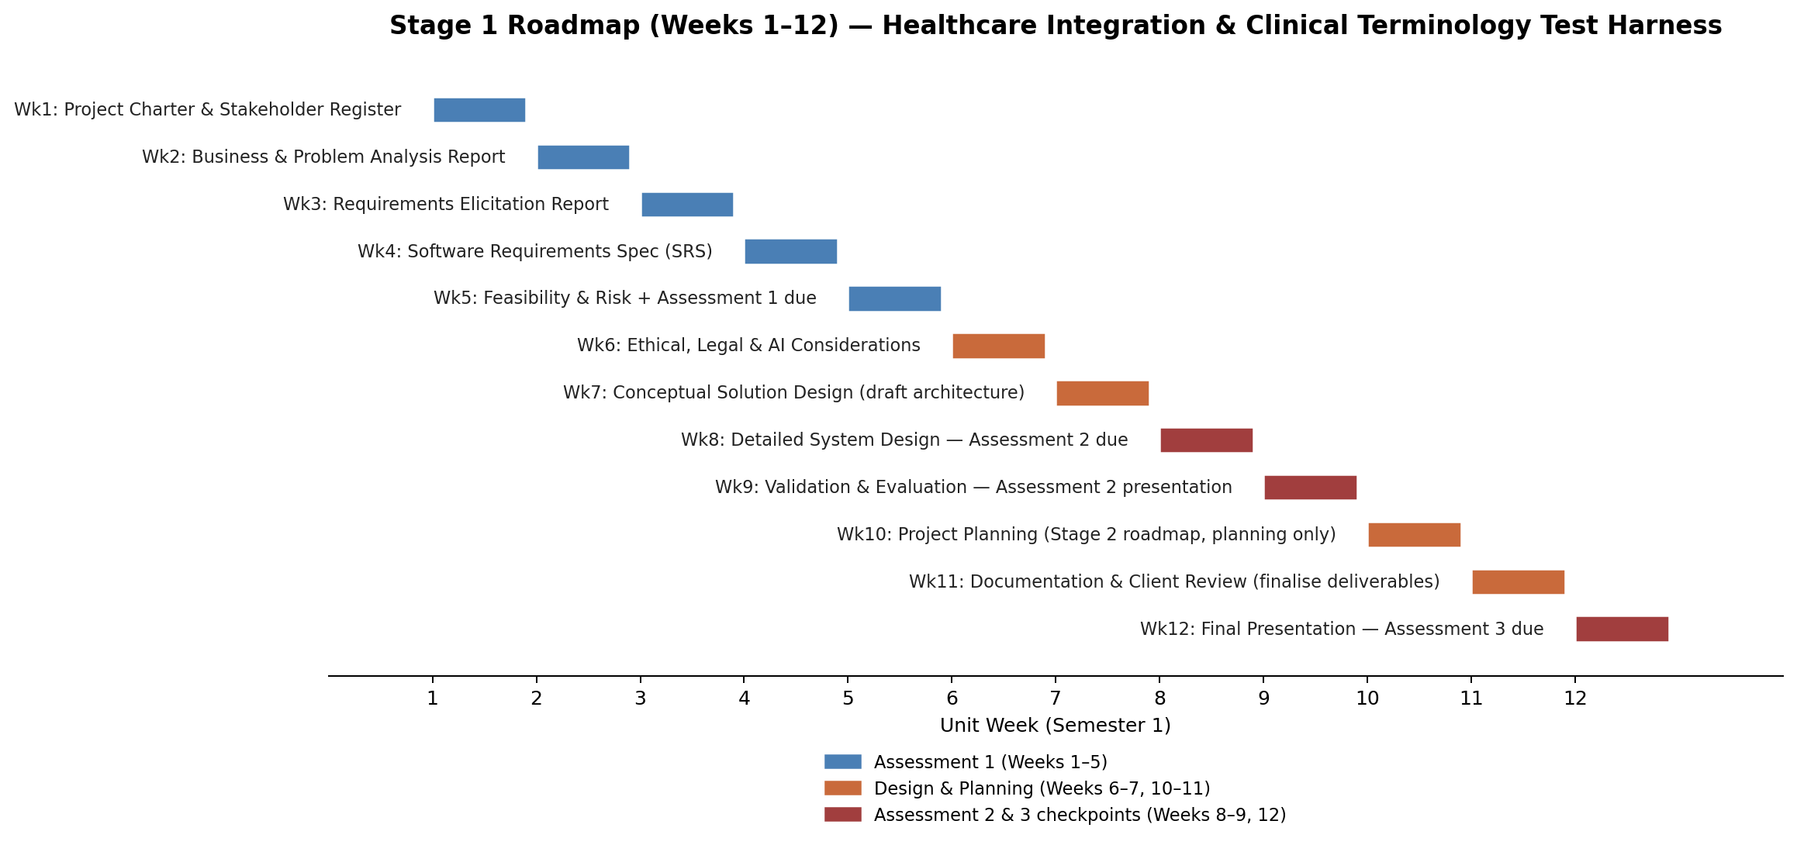

Weekly Task Breakdown
Week / Unit Topic | Sonam (BA & Documentation Lead) | Charity (Clinical Data Specialist) | Rikesh (Integration & FHIR Specialist) | Zubair (Testing & QA Lead) | Weekly Deliverable
Week 1 Project Initiation | Lead project charter drafting; background research on FAZ Australia/MedTalk; coordinate stakeholder register | Research MedTalk clinical workflows and how synthetic data will be scoped | Research FHIR fundamentals; Best Practice & Halo Connect overview | Set up GitHub/Jira structure; draft team working agreement | Project charter & stakeholder register
Week 2 Business & Problem Analysis | Lead organisation/process profile, root-cause analysis, SWOT | Provide evidence on current clinical coding/data-mapping gaps | Provide evidence on current integration/architecture gaps | Compile challenge & impact table, evidence log | Business & problem analysis report
Week 3 Requirements Elicitation | Facilitate elicitation sessions; consolidate requirements | Draft clinical/data requirements (SNOMED CT-AU → ICD-10-AM/MBS needs) | Draft FHIR/Halo Connect functional requirements | Draft non-functional requirements (failure conditions, performance, security) | Requirements elicitation report
Week 4 Requirements Analysis | Prioritise & validate requirements; consolidate use cases | Write use cases for data-mapping scenarios | Write use cases for FHIR integration flows | Define acceptance criteria & requirements traceability | Software Requirements Specification (SRS)
Week 5 Feasibility & Risk (Assessment 1 due) | Compile and submit full Assessment 1 portfolio | Assess feasibility of the synthetic data approach | Assess technical feasibility of FHIR integration | Build risk register & mitigation strategies | Feasibility study, risk register + Assessment 1 submitted
Week 6 Ethical, Legal & AI Considerations | Document Privacy Act 1988 (APPs) & My Health Records Act compliance approach | Address ethical handling of synthetic clinical data & SNOMED CT-AU licensing | Address data governance for FHIR message exchange | Address AI governance considerations for MedTalk's AI scribe | Ethical/legal/AI considerations summary
Week 7 Conceptual Solution Design | Coordinate overall solution concept across team | Draft conceptual synthetic patient data model | Draft conceptual architecture: FHIR resources, Halo Connect touchpoints | Draft conceptual test approach outline | Conceptual architecture diagram (draft)
Week 8 Detailed System Design (Assessment 2 due) | Consolidate detailed design documentation | Detailed synthetic patient records design; SNOMED CT-AU coding structure | Detailed FHIR interface design: API endpoints, message flow | Define security controls & test-data validation rules | Architecture diagram + FHIR design document (Assessment 2)
Week 9 Validation & Evaluation (Assessment 2 presentation) | Present overall solution to panel/client | Validate SNOMED CT-AU → ICD-10-AM/MBS mapping against requirements | Validate FHIR design against Australian Digital Health standards | Validate draft test plan against quality attributes | Assessment 2 presentation + validated design
Week 10 Project Planning | Draft Stage 2 implementation roadmap & resource plan | Plan approach for loading synthetic data in Stage 2 | Plan approach for building test environment/connectors in Stage 2 | Cost estimate & risk mitigation strategies for Stage 2 | Stage 2 implementation roadmap (planning only)
Week 11 Documentation & Client Review | Incorporate mentor/client feedback across all documents | Finalise synthetic test-data plan & data mapping document | Finalise FHIR integration design document | Finalise written test plan; coordinate peer review | Finalised Stage 1 documentation package
Week 12 Final Presentation (Assessment 3 due) | Present and defend Stage 1 solution to client/assessment panel (whole team) |  |  |  | Architecture diagram, synthetic test-data plan, written test plan + Assessment 3
Note: Shaded rows mark formal assessment checkpoints (Weeks 5, 8, 9, and 12). Task allocation will be refined by the team as work progresses and confirmed weekly in Jira.

Team Responsibilities Throughout the Project

Team Member 1 – BA & Architecture Lead (Sonam)
- Business analysis & requirements management

- Project planning and coordination

- Overall architecture design

- Final documentation review

Team Member 2 – Integration & FHIR Specialist (Rikesh)
- Research Best Practice and Halo Connect
- Design FHIR interfaces
- API and data flow documentation
- Integration review
Team Member 3 – Clinical Data Specialist (Charity)
- Design synthetic patient records
- SNOMED CT-AU coding
- ICD-10-AM mapping
- MBS mapping validation
Team Member 4 – Testing & Documentation Lead (Zubair)
- Develop test strategy
- Design test cases
- Risk analysis

